**Project name: Frontend**

Overview and Objective

I have created a frontend page which shows “about us” of any company. Shows a brief detail of any company. So, the page which is in the index.html is showing about **Kisan Network.**

Deployed Link:

<https://inspiring-snyder-568b17.netlify.app/>

GitHub repository

<https://github.com/prashantsinghmangat/frontend-project/tree/main/frontend>

Quick start and installation steps

1. Unzip the frontend.zip file
2. Open the folder and search for “index.html”
3. Open the index.html file and this will ready to view in browser
4. If need to see the CSS then search for “Style.css” and you can open it in any coding software like VS code.
5. Do refresh (Ctrl+R) if component not loaded map needs Internet access.

Content It contains

* Company name
* Company Logo
* Header
* Short intro
* Brief intro
* More in this series
* Related articles
* Submenu
* Contact Details
* Map or location
* Footer

Zip consists of 4 folders, index.html and style.css.

CSS folders contains all the files related to responsive, style, bootstrap.

Font folder consists of fonts.

Images folder consists of logo and images

JS folder consists of JavaScript

STYLE GUIDE & ICONS

Logo and Favicon

 

Favicon Round circle Logo

Color Palette

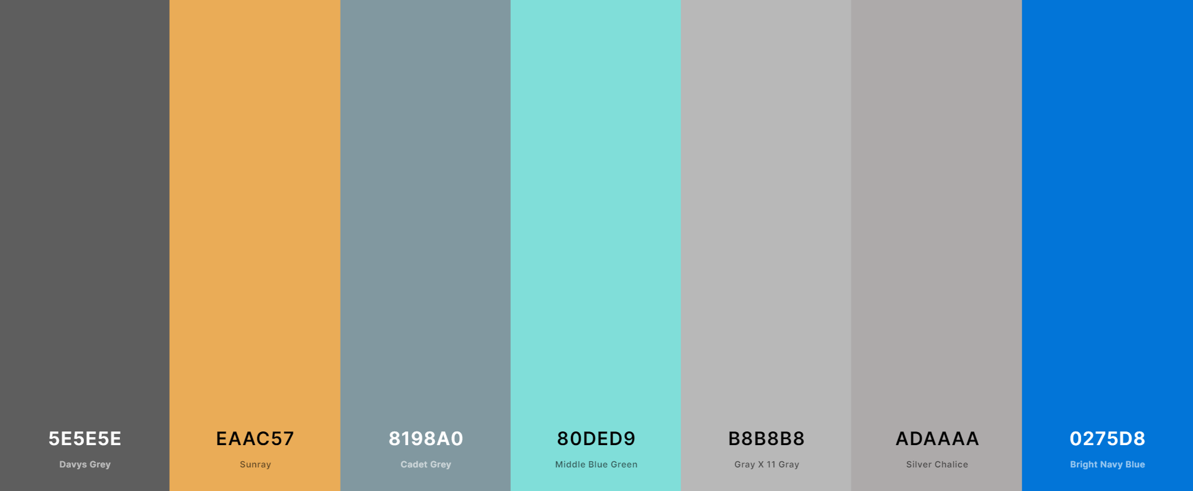

Typography

First and foremost, typography is about usability. Type is the user interface for conveying information, and conveying information is what we’re here to do on the web. There are many levers we can pull to affect the usability of reading text, and only by being deliberate about these can we create a pleasant experience for our users.

font-family: ‘Open Sans’, sans-serif;

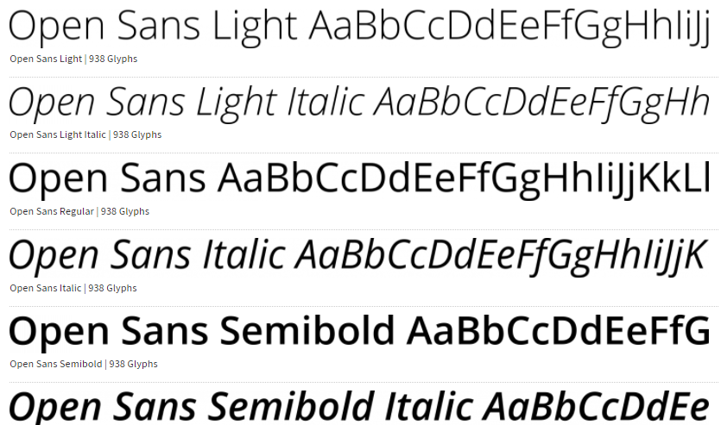

MOBILE APPLICATION DESIGN

 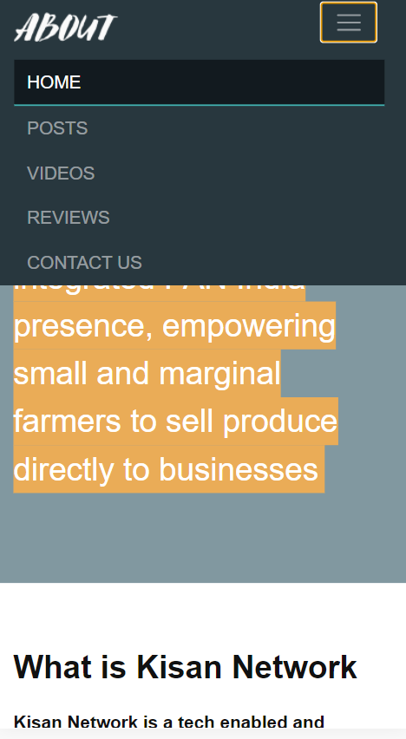 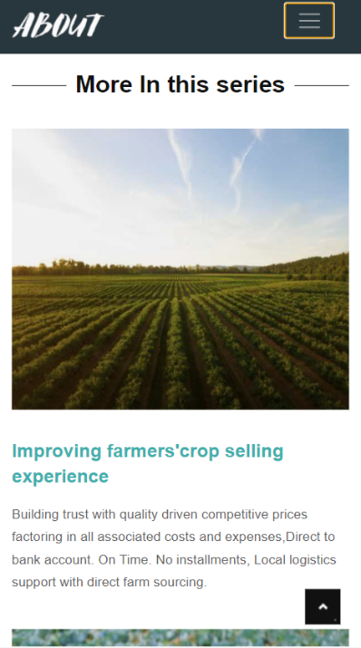

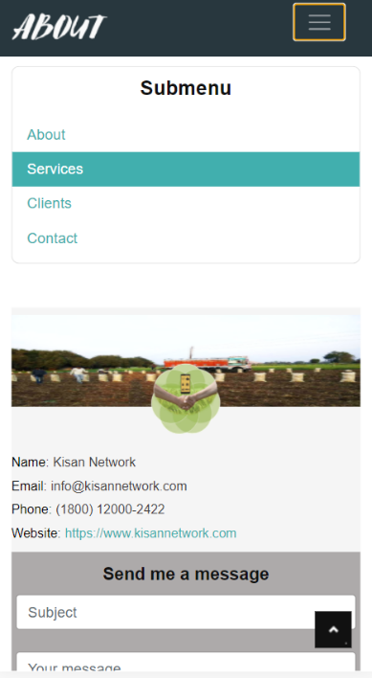 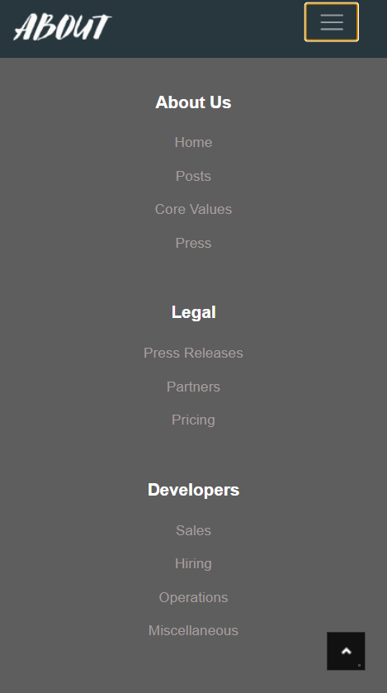

Important Tags in index:

**<mark> </mark> For highlighting the Text.**

**<article> </article> For article divisions.**

**<figure> </figure> For the section which contains Images.**

**<figcaption> <figcaprtion> For declaring the caption of figure.**

**<small> </small> For small text.**

**<nav> </nav> For navigations.**

**<section> </section> For defining any particular area or section.**

**<iframe> </iframe> For showing maps in page.**

**<footer> </footer> For showing footer.**

**shape-outside: inset(100px 10px 20px 10px); used for para breaking. (example below)**

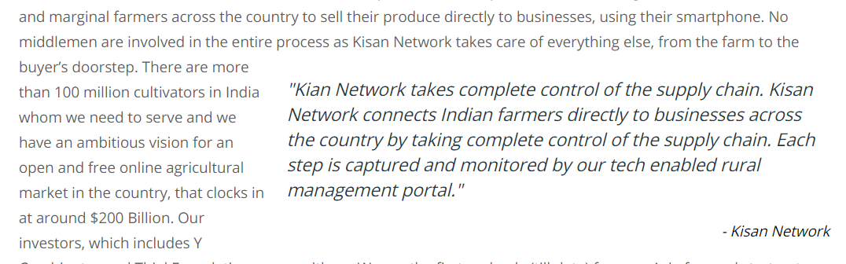

Reference:

Map Link for Kisan Network: <iframe src=<https://www.google.com/maps/embed?pb=!1m18!1m12!1m3!1d3506.080516065668!2d77.0811944150798!3d28.507225182467366!2m3!1f0!2f0!3f0!3m2!1i1024!2i768!4f13.1!3m3!1m2!1s0x390d195ccd0f7b31%3A0x5b61a193eff7c0b!2sKisan%20Network!5e0!3m2!1sen!2sin!4v1615712111894!5m2!1sen!2sin> ></iframe>

For compressing the Image: <https://compressjpeg.com/>

For making logo: <https://www.canva.com/>

For hosting and deploy; [https://app.netlify.com/sites/](https://app.netlify.com/sites/elated-lalande-e20a7f/overview)

For code commit and push: <https://github.com/prashantsinghmangat/frontend-project/tree/main/frontend>

Developed By: Prashant Singh

Contact No. 9457182128

Email: prashantsinghmangat5@gmail.com